
Semester Two Examination, 2024
Question/Answer booklet

MATHEMATICS METHODS
UNITS 3&4
Section One: Calculator-free

Your name

Your Teacher’s name

Time allowed for this section
Reading time before commencing work: five minutes
Working time: fifty minutes

Materials required/recommended for this section
To be provided by the supervisor
This Question/Answer booklet
Formula sheet

To be provided by the candidate
Standard items: pens (blue/black preferred), pencils (including coloured), sharpener,
correction fluid/tape, eraser, ruler, highlighters

Special items: nil

Important note to candidates
No other items may be taken into the examination room. It is your responsibility to ensure that you do not have any unauthorised material. If you have any unauthorised material with you, hand it to the supervisor before reading any further.

Question | Mark | Max | Question | Mark | Max
1 |  | 4 | 5 |  | 6
2 |  | 7 | 6 |  | 5
3 |  | 5 | 7 |  | 7
4 |  | 8 | 8 |  | 8

Structure of this paper

Section | Number of  questions  available | Number of  questions to  be answered | Working  time  (minutes) | Marks  available | Percentage  of  examination
Section One:  Calculator-free | 8 | 8 | 50 | 50 | 32.9
Section Two:  Calculator-assumed | 11 | 11 | 100 | 102 | 67.1
 |  |  |  | Total | 100

Instructions to candidates

1. The rules for the conduct of examinations are detailed in the school handbook. Sitting this examination implies that you agree to abide by these rules.

2. Write your answers in this Question/Answer booklet preferably using a blue/black pen.
Do not use erasable or gel pens.

3. You must be careful to confine your answers to the specific question asked and to follow any instructions that are specific to a particular question.

4. Show all your working clearly. Your working should be in sufficient detail to allow your answers to be checked readily and for marks to be awarded for reasoning. Incorrect answers given without supporting reasoning cannot be allocated any marks. For any question or part question worth more than two marks, valid working or justification is required to receive full marks. If you repeat any question, ensure that you cancel the answer you do not wish to have marked.

5. It is recommended that you do not use pencil, except in diagrams.

6. Supplementary pages for planning/continuing your answers to questions are provided at the end of this Question/Answer booklet. If you use these pages to continue an answer, indicate at the original answer where the answer is continued, i.e. give the page number.

7. The Formula sheet is not to be handed in with your Question/Answer booklet.
Section One: Calculator-free (50 Marks)
This section has eight questions. Answer all questions. Write your answers in the spaces provided.

Working time: 50 minutes.

Question 1 (4 marks)

The random variable $X$ denotes the number of people who cross a particular road in a ten-minute interval.

The random variable is found to have the following probability distribution:

$$x$$ | $$0$$ | $$1$$ | $$2$$ | $$3$$ | $$4$$ | $$5$$
$$Pr⁡(X=x)$$ | $$a$$ | $$2a$$ | $$4a$$ | $$4a$$ | $$8a$$ | $$a$$

(a) Show that $a=0.05$. (1 mark)

Solution
$$a+2a+4a+4a+8a+a=1$$
$$20a=1$$
$$a=\frac{1}{20}$$

Specific behaviours
ü Sums probabilities to 1 and solves for $a$.

(b) Determine the expected number of people who will cross this intersection in a ten-minute interval. (2 marks)

Solution
$$1×0.1+2×0.2+3×0.2+4×0.4$$
$$+5×0.05=2.95$$

Specific behaviours
- Valid calculation to determine expected value.
- Determines expected value. (accept decimal or rounded)

During the morning it is thought that a better model would be described by the random variable $Y$, where $Y=2X+1$.

(c) Determine the expected number of people who will cross this intersection in a ten-minute interval in the morning. (1 mark)

Solution
$$2×2.95+1=6.9 people$$

Specific behaviours
- Applies change of scale and origin correctly.(accept decimal or rounded)

Question 2 (7 marks)
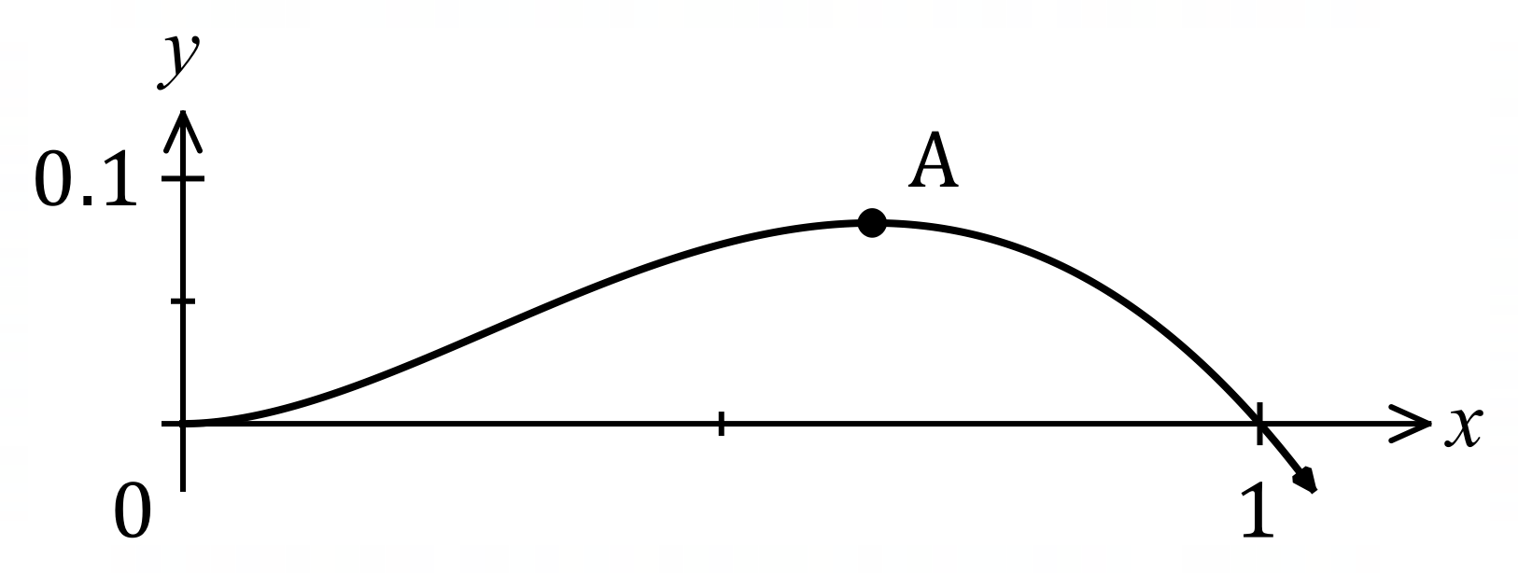
The graph of $y=f(x)$ is shown,
where $f\left(x\right)=x^{2}\left(1-\sqrt{x}\right)$.

(a) Determine the $x$-coordinate of the stationary point marked $A$ in the graph. (4 marks)

Solution
Derivative:
$$f^{'}\left(x\right)=2x\left(1-\sqrt{x}\right)+x^{2}\left(-\frac{1}{2\sqrt{x}}\right) \text{or} f\left(x\right)=x^{2}-x^{2.5}→f^{'}\left(x\right)=2x-2.5x^{1.5}$$
Stationary point:
$$f^{'}\left(x\right)=0 \\ 2x-2.5x\sqrt{x}=0 \\ x\left(2-2.5\sqrt{x}\right)=0 \\ \sqrt{x}=\frac{2}{2.5}=\frac{4}{5}⇒x=\frac{16}{25}$$

Specific behaviours
ü indicates use of product rule or expands $f(x)$
ü correct derivative
ü simplifies and factors $f^{'}\left(x\right)=0$
ü correct value of $x$

(b) Determine the area between the curve and the $x$-axis between $x=0$ and $x=1$.
(3 marks)
Solution
$$A=\int_{0}^{1}{\left(x^{2}-x^{2.5}\right)}dx \\ ={\left[\frac{x^{3}}{3}-\frac{x^{3.5}}{3.5}\right]}_{0}^{1} \\ =\frac{1}{3}-\frac{1}{3.5}=\frac{1}{3}-\frac{2}{7}=\frac{1}{21} \text{sq units}$$

Specific behaviours
ü writes correct integral
ü correct antiderivative
ü correct area

Question 3 (5 marks)
(a) Express using natural logarithms the $x$-coordinate of the point where the curve $y=3^{-x}$ intersects with the curve $y=5^{2-3x}$. (3 marks)
Solution
$$5^{2-3x}=3^{-x} \\ \ln\left(5^{2-3x}\right)=\ln\left(3^{-x}\right) \\ \left(2-3x\right)\ln{5}=-x\ln{3} \\ 2\ln{5}-3x\ln{5}+x\ln{3}=0 \\ x\left(\ln{3}-3\ln{5}\right)=-2\ln{5} \\ x=\frac{2\ln{5}}{3\ln{5}-\ln{3}}$$

Specific behaviours
ü uses log laws to obtain linear equation in $x$
ü collects like terms
ü correct $x$-coordinate

(b) Given that $f(x)$ has domain $x>-3$, has derivative $f^{'}\left(x\right)=\begin{matrix}1 \\ \overline{x+3}\end{matrix}$, and the curve $y=f(x)$ passes through the point $(-2, 5)$, determine an expression for $f(x)$. (2 marks)
Solution
$$f\left(x\right)=\int{\frac{1}{x+3}}dx \\ =\ln{(x+3)}+c$$
Using $\left(-2, 5\right)$:
$$5=\ln{(1)}+c⇒c=5$$

$$f\left(x\right)=\ln{(x+3)}+5$$

Specific behaviours
ü correct antiderivative
ü correct $f(x)$ including solved constant

Question 4 (8 marks)
Determine the following:

(a) $\int{\underset{ }{18\sin\left(6x+1\right)}}dx$. (2 marks)
Solution
$$\int{\underset{ }{18\sin\left(6x+1\right)}}dx=-3\cos{(6x+1)}+c$$

Specific behaviours
ü correct antiderivative
ü constant of integration

(b) $\int_{2}^{3}{\begin{matrix}d \\ \overline{dx}\end{matrix}\left(\cos\left(\begin{matrix}πx \\ \overline{ 3 }\end{matrix}\right)\right) }dx$. (2 marks)
Solution
$$\int_{2}^{3}{\begin{matrix}d \\ \overline{dx}\end{matrix}\left(\cos\left(\begin{matrix}πx \\ \overline{ 3 }\end{matrix}\right)\right) }dx={\left[\cos\left(\begin{matrix}πx \\ \overline{ 3 }\end{matrix}\right)\right]}_{2}^{3} \\ =\cos\left(\begin{matrix}3π \\ \overline{ 3 }\end{matrix}\right)-\cos\left(\begin{matrix}2π \\ \overline{ 3 }\end{matrix}\right) \\ =-1-\left(-1/2\right)$$
$$= {-1}/2$$

Specific behaviours
ü eliminates integral
ü correct value

(c) $\int_{1}^{4}{\underset{ }{\sqrt{3x-3}}}dx$. (2 marks)
Solution
$$\int_{1}^{4}{\underset{ }{\sqrt{3x-3}}}dx=\int_{1}^{4}{{\left(3x-3\right)}^{\frac{1}{2}}}dx \\ ={\left[\frac{1}{3}×\frac{2}{3}×{\left(3x-3\right)}^{\frac{3}{2}}\right]}_{1}^{3} \\ =\frac{2}{9}{\left(9\right)}^{\frac{3}{2}}-0 \\ =6$$

Specific behaviours
ü correct antiderivative
ü correct value

(d) $\begin{matrix}d \\ \overline{dy}\end{matrix}\int_{y}^{-1}{(1-\underset{ }{{3e}^{2x+π})}}dx$. (2 marks)
Solution
$$\begin{matrix}d \\ \overline{dy}\end{matrix}\int_{y}^{-1}{(1-\underset{ }{{3e}^{2x+π})}}dx=\begin{matrix}d \\ \overline{dy}\end{matrix}\int_{-1}^{y}{\underset{ }{{(3e}^{2x+π}-1)}}dx={3e}^{2y+π}-1$$

Specific behaviours
ü indicates use of fundamental theorem
ü correct expression

Question 5 (6 marks)

The time taken to wait for a self-service checkout in a supermarket, $X$ minutes, is a continuous random variable.

The wait time is modelled by the cumulative distribution given by

$$F\left(x\right)=-\left(2x+1\right)e^{-2x} where x≥0$$

(a) Determine the exact probability that a customer will wait between two and three minutes for a self-service checkout. (2 marks)

Solution
$$F\left(3\right)-F\left(2\right)=-7e^{-6}+5e^{-4}$$

Specific behaviours
- Correct expression for probability.
- Correct answer.

(b) Show that the probability density function is given by $f\left(x\right)=4xe^{-2x}$. (3 marks)

Solution
$$f\left(x\right)=\frac{d}{dx}\left(-\left(2x+1\right)e^{-2x}\right)$$
$$=-2e^{-2x}-\left(2x+1\right)\left(-2e^{-2x}\right)$$
$$=-2e^{-2x}+4xe^{-2x}+2e^{-2x}$$
$$f\left(x\right)=4xe^{-2x}$$

Specific behaviours
- Recognises that the probability density function is the derivative of the cumulative distribution.
- Uses product rule.
- Correctly differentiates and simplifies..

A graph of $f\left(x\right)=4xe^{-2x}$ is shown below.

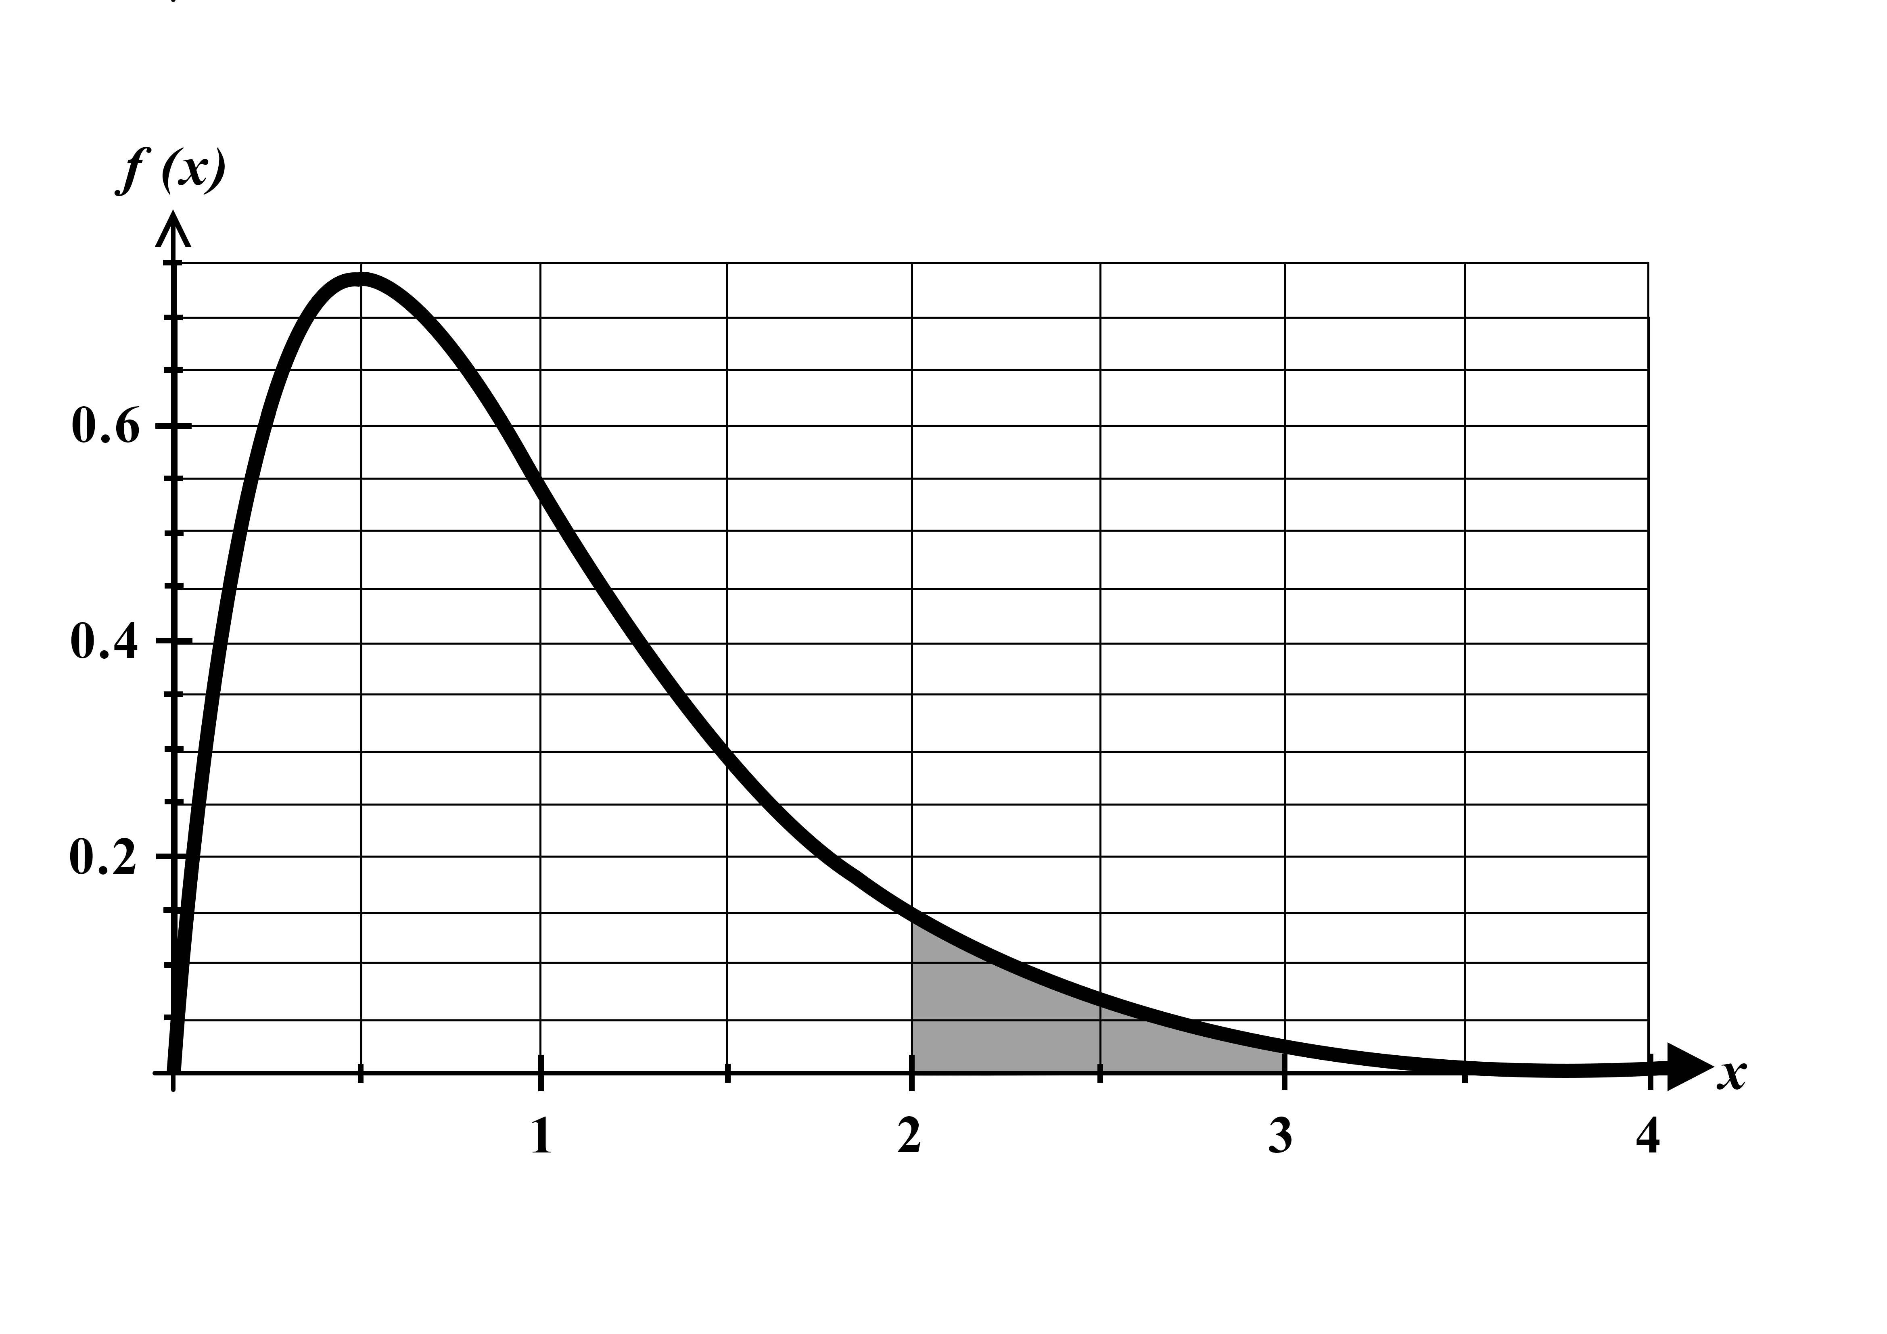

(c) Illustrate your solution to part (a) on the above graph. (1 mark)

Solution
$$Shades area under the curve from$$
$$x=2 to x=3.$$

Specific behaviours
- Shades correct area.

Question 6 (5 marks)

(a) A survey of 400 randomly selected Year 12 students found 20% of them were in favour of shorter summer holidays.

Using $z=2$, determine an approximate 95% confidence interval for the proportion of all Year 12s in favour of shorter summer holidays. (3 marks)

Solution
$$p=0.2$$
$$E=2\sqrt{\frac{0.2\left(0.8\right)}{400}}=\frac{2×\frac{2}{5}}{20}=\frac{1}{25}=0.04$$
$$Confidence interval:$$
$$0.16≤p≤0.24 or 16\%≤p≤24\%$$

Specific behaviours
- Uses $z=2$.
- Determines margin of error.
- Determines simplified confidence interval.

(b) In order to estimate how many people would vote for a particular political party, $p$, a group of randomly selected voters is surveyed. The survey resulted in a $95\%$ symmetrical confidence interval of $0.498<p<0.522$.

Below are five statements about this confidence interval. Tick the two correct statements.
(2 marks)

The probability that a randomly selected voter will vote for the party is between $0.498$ and $0.522$.
A 90% confidence interval determined based on the data collected would have a smaller interval width.
Assuming that the proportion of voters in the sample remains the same, increasing the sample size would lead to a reduction in the 95% confidence interval.
The probability that party A will receive a vote share of more than 52.2% is 5%.
A majority of voters would vote for this political party in an election.

Solution
$$2nd and 3rd statements are correct$$

Specific behaviours
- Ticks 2nd statement.
- Ticks 3rd statement.
Note: zero marks out of two if more than two selected

Question 7 (7 marks)
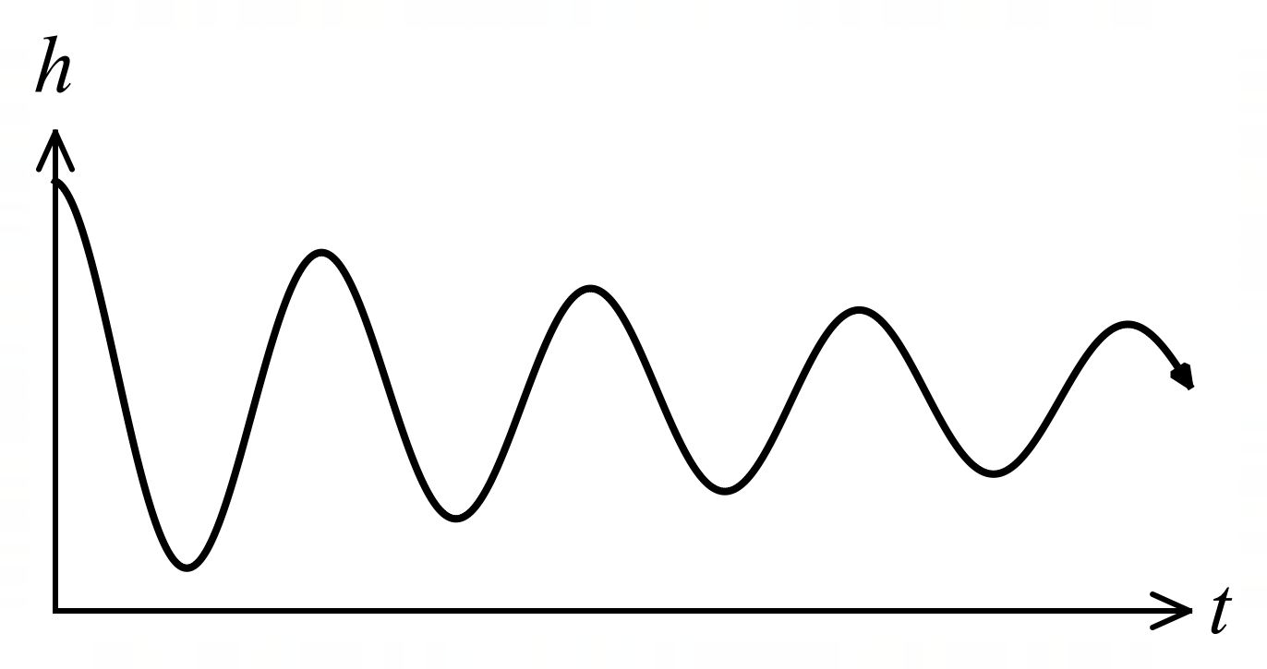
The graph shows the height $h$ cm of
a small mass suspended by a spring
above a bench top $t$ seconds after it
was released, where
$$h=3+\frac{3\cos\left(4πt\right)}{t+1}.$$

(a) Calculate the height of the mass when $t=1$. (1 mark)
Solution
$$h\left(1\right)=3+\frac{3\cos\left(4π\right)}{2}=3+\frac{3}{2}=4.5 \text{cm}$$

Specific behaviours
ü correct height with units

(b) Determine the rate of change of height of the mass when $t=1$. (3 marks)

Solution
$$\frac{dh}{dt}=\frac{-12π\sin\left(4πt\right)\left(t+1\right)-3\cos\left(4πt\right)}{{\left(t+1\right)}^{2}}$$

When $t=1$
$$\frac{dh}{dt}=\frac{-12π\sin\left(4π\right)\left(2\right)-3\cos\left(4π\right)}{2^{2}} \\ =\frac{0-3}{4}=-\frac{3}{4} \text{cm/s}$$

Specific behaviours
ü evidence of use of quotient rule
ü correct derivative
ü correct rate of change (no need for units)

(c) Use the increments formula to estimate the height of the mass when $t=1.1$. (3 marks)
Solution
$$δh≈δt×\frac{dh}{dt} \\ ≈(1.1-1)×-\frac{3}{4} \\ ≈-0.075$$

Height will be $h\left(1\right)-0.075=4.5-0.075=4.425$ cm.

Specific behaviours
ü indicates correct use of increments formula (all values substituted)
ü evaluates change in height
ü correct height (no need of units)

Question 8 (8 marks)

(a) Show using calculus that the derivative of $y=\tan{x}$ is $\frac{dy}{dx}=1+\tan^{2}{x}$. (3 marks)
Solution
$$y=\frac{\sin{x}}{\cos{x}}$$
$$\frac{dy}{dx}=\frac{\cos{x}\cos{x}-\left(-\sin{x}\right)\sin{x}}{{\left(\cos{x}\right)}^{2}}$$
$$\frac{dy}{dx}=\frac{\cos^{2}{x}}{\cos^{2}{x}}+\frac{\sin^{2}{x}}{\cos^{2}{x}}$$
$$\frac{dy}{dx}=1+\tan^{2}{x}$$

Specific behaviours
- Writes $\tan{x}$ as a quotient and uses quotient rule.
- Correctly differentiates
- Shows how to arrive at required result using pythagorean
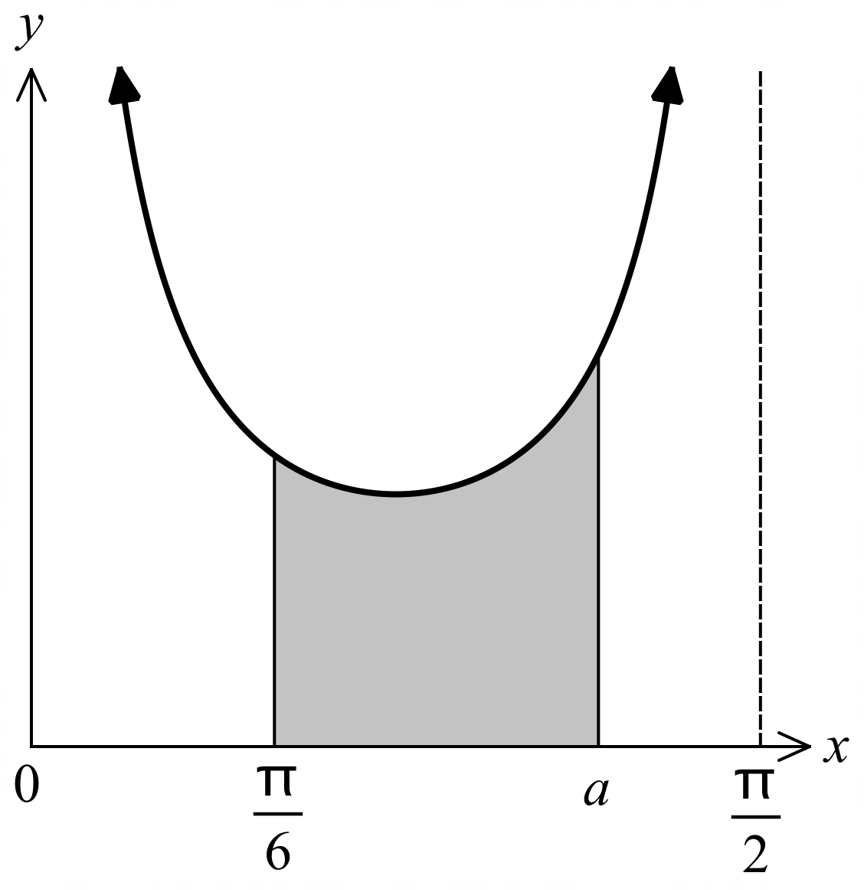

The diagram on the right shows the graph of

$$y=\frac{1+\tan^{2}{x}}{\tan{x}}$$

for $0≤x≤\frac{π}{2}$.

The shaded area is bounded by the curve, the $x$-axis and the lines $x=\frac{π}{6}$ and $x=a$.

(b) Using part (a), determine the exact value of $a$ if the shaded area is $\ln{3}$ square units.
(5 marks)
Solution
$$\int_{\frac{π}{6}}^{a}{\frac{1+\tan^{2}{x}}{\tan{x}}}dx=\ln{3}$$
$${\left[\ln\left(\tan{x}\right)\right]}_{\frac{π}{6}}^{a}=\ln{3}$$
$$\ln{(\tan{a})}-\ln\left(\tan{\frac{π}{6}}\right)=\ln{3}$$
$$\ln{(\tan{a)}}-\ln{\frac{1}{\sqrt{3}}}=\ln{3}$$
$$\ln{(\tan{a})}=\ln{3}+\ln{\frac{1}{\sqrt{3}}}$$
$$\ln\left(\tan{a}\right)=\ln{\frac{3}{\sqrt{3}}}….(1)$$
$$\tan{a}=\sqrt{3}$$
$$a=\frac{π}{3}$$

Specific behaviours
- Sets up a correct integral to determine the area.
- Correctly integrates $\frac{1+\tan^{2}{x}}{\tan{x}}$.
- Substitutes in bounds.
- Uses law logs correctly to arrive at (1).
- Solves for $a$.

